

Search

David Murphy

25 June  [Strategy](https://messapps.com/tag/strategy/)

**Restaurant Apps – A Closer Look At The Numbers**

***As more and more customers plug into the grid, your restaurant's internet presence will be that much more crucial.***

[OpenTable](http://www.opentable.com/start/home) ­ an app with a 4.5 star rating and over 50,000+ reviews that lets users make reservations at local restaurants ­ [conducted a survey](http://nrn.com/consumer-trends/report-consumers-hungry-more-restaurant-technology) in 2015 to help restaurants understand how diners would like their mobile apps to function. Over 6,000 adults

were surveyed in different metropolitan areas around the United States and **approximately 76% of those surveyed agreed that incorporating technology into their dining experience would be a tremendous improvement.**

To debunk what restaurants *think* diners might expect out of the restaurant’s app, a surprising 86% of respondents could not see themselves pre­ordering a meal and an even higher 88% said they probably wouldn’t make a purchase beforehand. So what are some of the things diners seek in mobile apps? The results were surprisingly unanimous:

* 87% wanted an app that could find local restaurants
* 86% simply wished to view a restaurant's menu
* 85% wanted to know how long the wait would be
* 83% wished they could add themselves to the wait­list before arriving

* 68% thought it’d be convenient to choose their own table
* 60% wanted to read reviews for the restaurant
* 48% would prefer to read reviews from professional critics

Diners seem to have nothing but great things to say about technology, so why not plug into the grid with an app of your own? If you aren’t already aware, **the large majority of restaurants are adapting touch­screen technology into their services to help both improve and expedite the ordering process.**

On­table touchscreens have been trending the United States in recent times: I recall using one myself at several Applebees across New York State. When respondents were asked about these touchscreens, **55 percent said that they too had used them before, and four out of five seemed to enjoy or at the very least felt neutral about them.**

[**A similar study was made two years prior by Telmetrics and xAd**](http://marketingland.com/study-50-percent-of-mobile-queries-in-travel-restaurants-autos-result-in-a-purchase-18404); it was found that **89% of users who searched for a restaurant with their smartphone made a purchase within 24 hours and 64% made a transaction within the hour**. This 2012 study had already fortified the notion that **smartphone users are more likely to make a purchase than desktop**

**users.** So why not make their search easier with an app? In fact, 53% of respondents said they had searched for an app for

restaurants within their local directory**.**

had substantiated the above

demands of diners:

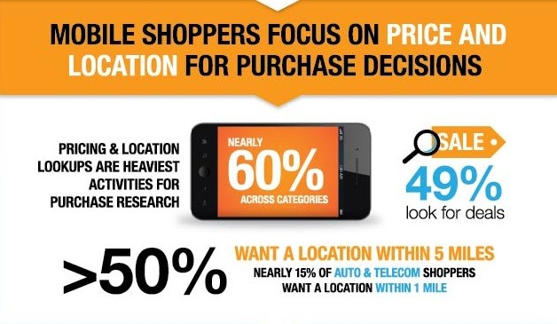

Source: telemetrics.com

Price and location are two big driving points for potential diners. The majority of users just want to know where your restaurant is, and how much their meal is going to cost.

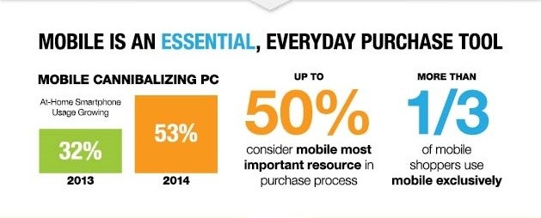

Source: telemetrics.com

Times are changing, and users expect to find what they want by simply reaching for their phone and pulling up information. If your restaurant can be easily found by a quick search on any old smartphone, then your business will be significantly impacted.

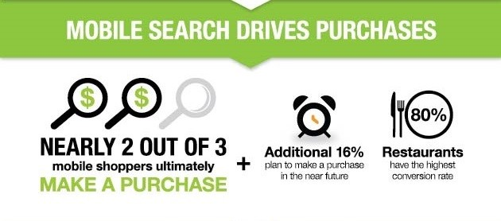

Source: telemetrics.com

Out of every other category, restaurant shoppers have the highest rate of conversion from potential consumers into paying customers. An app that’s personalized to your restaurant’s audience will ensure that users will enjoy their browsing experience and share it with friends and family, giving your restaurant that much more publicity.

**Ads seem to have a big impact on compelling potential diners into choosing a particular restaurant.** 3 out of 5 respondents in the 2012 Telmetrics and xAd survey claimed that they seldom know what they wanted to eat before making a search on their mobile device, and 75% reported to have noticed mobile ads particularly for restaurants. Funneling resources into developing and more importantly marketing and advertising a great, user­friendly app for your restaurant could be a big game­ changer for your business.

**As more and more customers plug into the grid with their smartphones, it’s important that your restaurant’s presence on the web doesn’t get left behind.** For more on how developing an app can help the discoverability of your restaurant, [check out our article on how to index an app with Google Search](https://messapps.com/academy/app-indexing-latest-greatest-marketing-2/).

0

You might also like this articles

Dominick Wojtas



25 July

# [Mobile App Design Guide: Sketch Vs. Photoshop](https://messapps.com/academy/articles/mobile-app-design-guide-sketch-vs-photoshop/)

The debate between Sketch and Photoshop is blazing stronger than ever. Photoshop has been the most commonly used tool when making mockups for mobile and web design for years. However, it seems that the days of Photoshop’s reign in the industry are no more. Sketch has been bubbling quietly for some time now but with the latest release of Sketch 3, I wouldn’t be surprised if Adobe is panicking about losing some of its market share.

0

Dominick Wojtas

05 December

# [Categories and Subcategories for App Store Optimization](https://messapps.com/academy/articles/categories-subcategories-app-store-optimization/)

There are several tactics to gaining more exposure on the app store. One strategy to optimize your app on the App Store is to use your app category listing effectively to lift your app to the top of the search.

1